STUDENT REPORT

**PREPARED BY:**

|  |  |
| --- | --- |
| **ASSOCIATE NAME** | **ASSOCIATE ID** |
| Anusha Maligireddy | 2149315 |
| Nivya K | 2151027 |
| Treeshali Sharma | 2147577 |
| Tharanitharan T | 2151015 |
| Rashi Wase | 2150250 |
| Bhanuri Madhumitha Reddy | 2148440 |

**GUIDED BY-**

|  |
| --- |
| **MENTOR COACH**  Kavin Kumar Govindaraj Gayathri Thyagaraju  Associate GenC Coach – CDB-AIA  AIA-Cloud Data Integration Human Resource - GenC  **LIST OF CONTENTS** |

* **Introduction**8
* **Purpose of the project** 8
* **About the Software System**8
* **Scope of the System** 8
* **Architecture Diagram** **9**
* **Flow Chart** 10
* **Functional Requirement 1**  11 - 13
  + Department Dimension
  + Sources
  + Target
  + Mapping
  + Workflow
* **Functional Requirement 2**14 - 17
  + Student Dimension
  + Sources
  + Target
  + Mapping
  + Transformation
  + Workflow
* **Functional Requirement 3**18 - 22
  + Marks Fact
  + Sources
  + Target
  + Mapping
  + Transformation
  + Workflow
* **Functional Requirement 4**22 - 26
  + Subject Average Aggregate
  + Sources
  + Target
  + Mapping
  + Transformation
  + Workflow
* **Functional Requirement 5**26 - 30
  + Subject Pass Percentage Aggregate
  + Sources
  + Target
  + Mapping
  + Transformation
  + Workflow
* **Integrated Workflow**31
* **Integrated Task Details** 31
* Gantt Chart View
* Task View
* **Design Constraints**33-34
* **Conclusion**34

**LIST OF ABBREVATIONS**

|  |  |
| --- | --- |
| **TECHNICAL TERM** | **DESCRIPTION** |
| ETL | Extraction, Transformation and Load |
| SRC | Source |
| TGT | Target |
| SQ | Source Qualifier |
| WF | Workflow |
| JNR | Joiner |
| EXP | Expression |
| AGG | Aggregator |

**LIST OF TABLES**

Table 1: Department Source Description

Table 2: Department Target Description

Table 3: Student Dimension Source Description

Table 4: Student Dimension Target Description

Table 5: Student Dimension Transformation Description

Table 6: Marks Fact Source Description

Table 7: Marks Fact Target Description

Table 8: Marks Fact Transformation Description

Table 9: Subject Average Aggregate Source Description

Table 10: Subject Average Aggregate Target Description

Table 11: Subject Average Aggregate Transformation Description

Table 12: Subject Pass Percentage Aggregate Source Description

Table 13: Subject Pass Percentage Aggregate Target Description

Table 14: Subject Pass Percentage Aggregate Transformation Description

**LIST OF FIGURES**

Fig 1: Architecture Diagram

Fig 2: Flow Chart

Fig 3:Department Source Definition

Fig 4:Department Target Definition

Fig 5:Department Target Table

Fig 6:Mapping 1

Fig 7:Workflow 1

Fig 8:Student Dimension Source Definition

Fig 9:Student Dimension Target Definition

Fig 10:Student Dimension Target Table

Fig 11:Mapping 2

Fig 12: Workflow 2

Fig 13: Marks_Fact Source Definition

Fig 14: Marks Fact Target Definition

Fig 15: Marks Fact Target Table

Fig 16: Mapping 3

Fig 17: Workflow 3

Fig 18: Subject Average Aggregate Source Definition

Fig 19: Subject Average Target Definition

Fig 20: Subject Average Target Table

Fig 21: Mapping 4

Fig 22: Workflow 4

Fig 23: Subject Pass Percentage Aggregate Source Definition

Fig 24: Subject Pass Percentage Aggregate Target Definition

Fig 25: Subject Pass Percentage Aggregate Target Table

Fig 26: Mapping 5

Fig 27: Workflow 5

Fig 28: Integrated Workflow Details

Fig 29: Integrated Task Details- Gantt Chart View

Fig 30: Integrated Task Details- Task View

##### Introduction

Informatica PowerCenter is used to complete the project "Student Report" in accordance with business requirements (ETL Tool). An ETL-based data integration tool is called Informatica. The popular tool for extraction, transformation, and loading is called Informatica PowerCenter. The Informatica PowerCenter components help to extract data from its source, convert it in accordance with business needs, and load it into a destination data warehouse. The "Student Report" system was created to organise the data of various students enrolled in a facility.

##### Purpose of the Project

The goal of this project is to create an analytical system that aids in the analysis of various possibilities for the provided data in accordance with business requirements. This document lists both the functional and non-functional requirements for this system.

##### About the Software System

An educational institution's sample data warehouse is loaded using the software system. Data from the source system is supplied as a flat file extract that is to be imported into a relational database in the data warehouse. The data that has been entered into the data warehouse will be used by the educational institution to make decisions.

##### Scope of the System

The scope of the system is to create and populate Data Warehouse tables.

##### ARCHITECTURE DIAGRAM

#### 

**Fig 1:** **Architecture Diagram**

##### FLOW CHART

Go to Informatica PowerCenter Designer

Import source files (Flat Files)

Import target files (Database)

1) Department_Dimension

2) Student_Dimension

3) Mark_Fact

4) Subject_Average_Aggregate

5) Subject_Pass_Percent_Aggregate

5

1) Department_Details

2) Student_Address

3) Student_Mark

4) Student_Details

Mapping and Applying Transformations

Designing Workflow

Output

**Fig 2: Flow Chart**

###### Functional Requirement 1

##### DEPARTMENT DIMENSION

##### SOURCE

##### Under the first functional requirement, to load the data into the Data Warehouse, we used the following source flat file i.e.

|  |  |  |
| --- | --- | --- |
| **SOURCE FILE NAME** | **DESCRIPTION** | **SOURCE FILE** |
| Dept_Details.txt | This is a Tab delimited file with 2 input fields. |  |

**Table 1: Department Source Description**

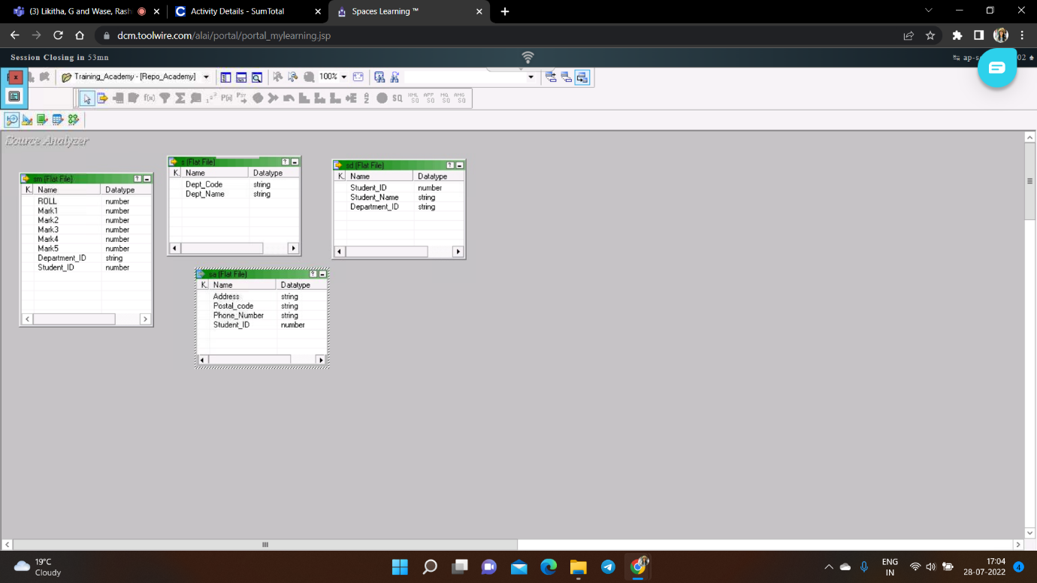

**Fig 3: Department Source Definition**

**TARGET**

The target table has been generated in the Oracle database by using the source files as mentioned above.

|  |  |  |
| --- | --- | --- |
| **TARGET NAME** | **DESCRIPTION** | **TARGET FILE** |
| tgt_Dept_Dimension.txt | Contains department ID and department name. |  |

**Table 2: Department Target Description**

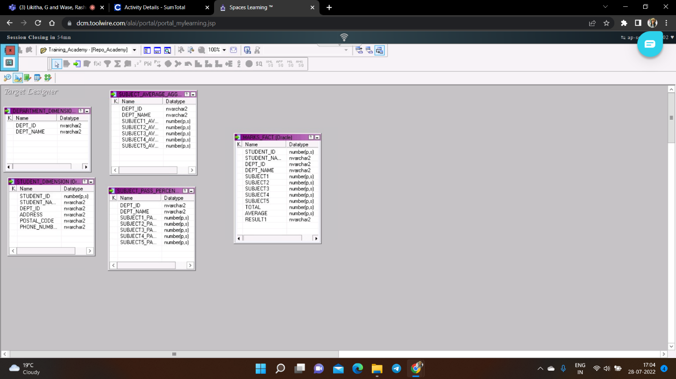

**Fig 4: Department Target Definition**

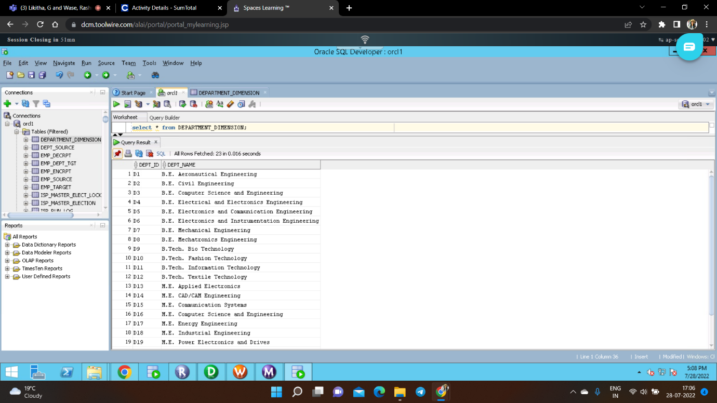

**Fig 5: Department Target Table**

**MAPPING**

The below figure shows the data flow from source to the target table by applying the necessary transformations to satisfy the business requirement

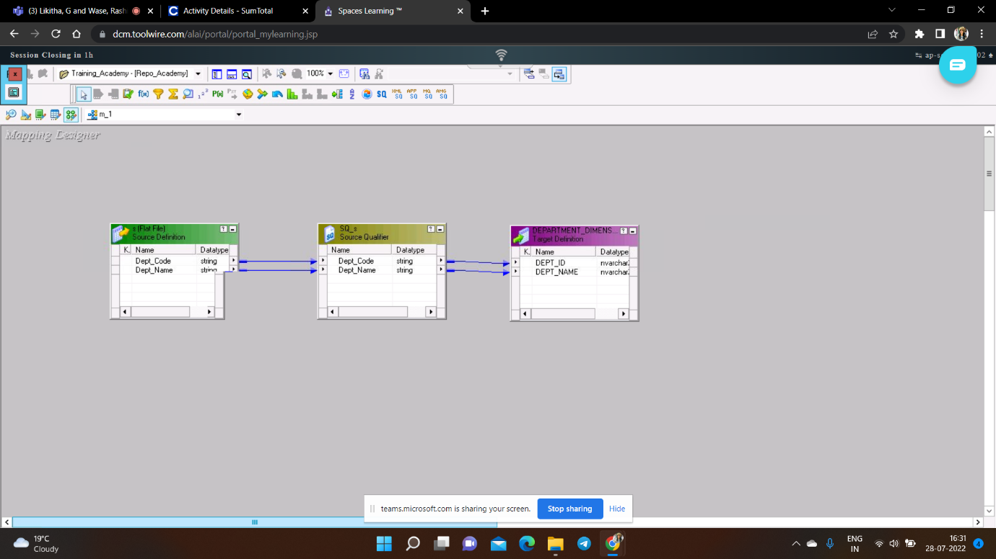

**Fig 6: Mapping 1**

**Workflow**

Below Figure shows the workflow which executes the mappings created in the designer.

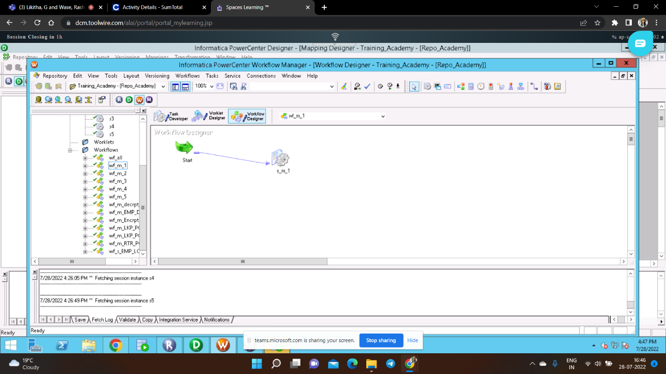

**Fig 7: Workflow 1**

###### Functional Requirement 2

**STUDENT DIMENSION TABLE**

##### SOURCE

Under the second functional requirement, to generate the student dimension table we created two source files i.e.

|  |  |  |
| --- | --- | --- |
| **SOURCE FILE NAMES** | **DESCRIPTION** | **SOURCE FILES** |
| Student_Det.txt | This is a tab delimited file containing 3 fields. |  |
| Student_Address.txt | This is a tab delimited file containing 4 fields. |  |

**Table 3: Student Dimension Source Description**



**Fig 8: Student Dimension Source Definition**

**TARGET**

The target table has been generated in the Oracle database by using the source files as mentioned above.

|  |  |  |
| --- | --- | --- |
| **TARGET NAME** | **DESCRIPTION** | **TARGET FILE** |
| tgt_Student_Dimension.txt | Contains students’ data namely Student_Id, Student_Name, Dept_Id, Address, Postal_Code and Phone_Number. |  |

**Table 4: Student Dimension Target Description**



**Fig 9: Student Dimension Target Definition**

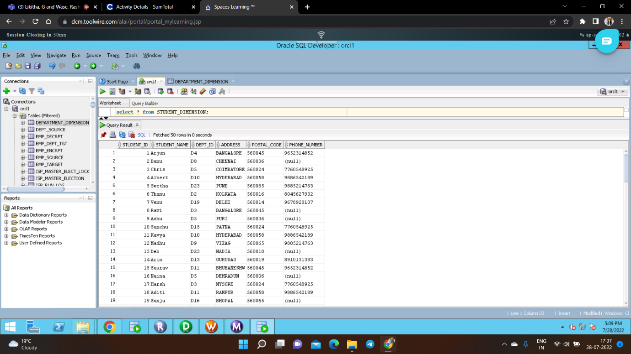

**Fig 10: Student Dimension Target Table**

**MAPPING**

The below figure shows the data flow from source to the target table by applying the necessary transformations to satisfy the business requirement.

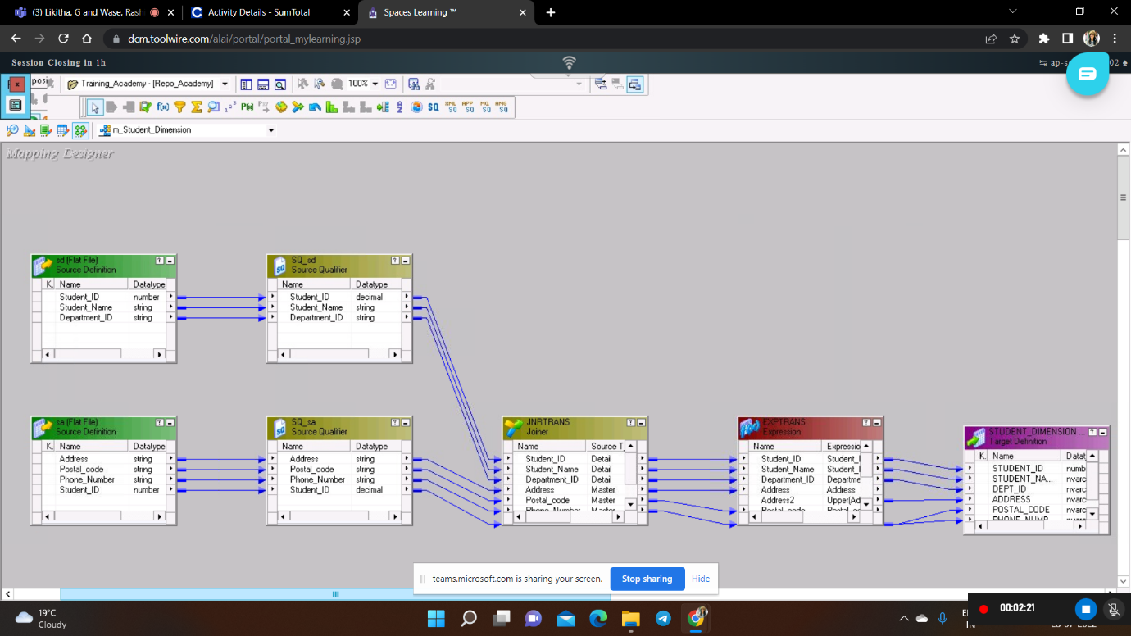

**Fig 11: Mapping 2**

**TRANSFORMATIONS:** The descriptions of the transformations used are mentioned in the table below.

|  |  |  |  |
| --- | --- | --- | --- |
| **TRANSFORMATION**  **NAME** | **DESCRIPTION** | **TRANSFORMATION**  **LOGIC** |  |
| **JNR [NORMAL JOIN]** | TO JOIN STUDENT_ADDRESS(DETAIL TABLE) AND STUDENT_DETAIL (MASTER TABLE) ON COMMON COLUMN STUDENT_ID BY USING NORMAL JOIN. | STUDENT_ID1=STUDENT_ID |  |
| **EXP (Port o_Postal_Code)** | TO REMOVE EXTRA SPACES AND SPECIAL CHARACTERS IN POSTAL_CODE COLUMN. | RTRIM(LTRIM(REG_REPLACE(Postal_code,'[^A-Z0-9a-z]',''))) |  |
| **EXP (Port o_Phone_Number)** | TO CHECK PHONE_NUMBER COLUMN IS CONTAINING VALID 10 DIGIT PHONE NUMBER.IF, ANY INVALID NUMBERS FOUND THEY WILL BE LOADED AS ‘NULL’. | IIF(REG_MATCH(Phone_Number,'(\d\d\d\d\d\d\d\d\d\d)'),Phone_Number,Null) |  |
| **EXP (Port o_Address)** | ALL CHARACTERS IN THE ADDRESS COLUMN ARE CONVERTED TO UPPER CASE | UPPER(Address) |  |

**Table 5: Student Dimension Transformation Description**

**Workflow:** Below Figure shows the workflow which executes the mappings created in the designer.

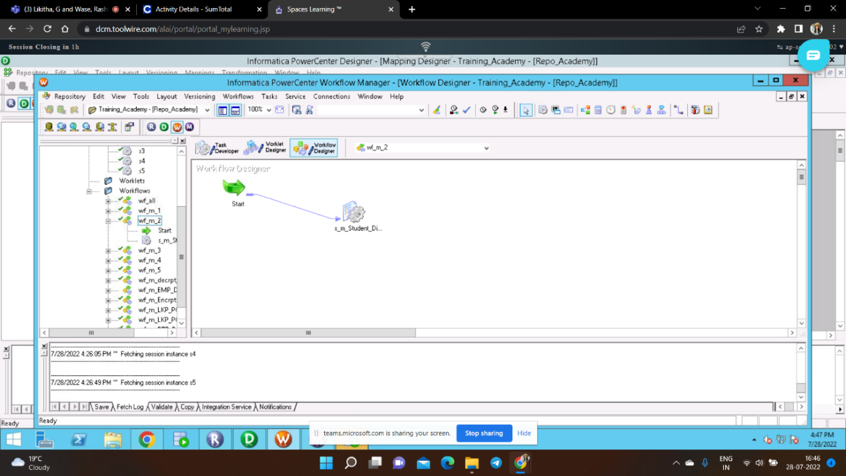

**Fig 12: Workflow 2**

###### Functional Requirement 3

**MARKS FACT**

**SOURCE**

Under the third functional requirement, to generate the marks Fact table, we created three source files i.e.

|  |  |  |
| --- | --- | --- |
| **SOURCE FILE NAMES** | **DESCRIPTION** | **SOURCE FILES** |
| Dept_Details.txt | This is a tab delimited file with two fields. |  |
| Student_Details.txt | This is a tab delimited file with four fields. |  |
| Student_Marks.txt | This is a tab delimited file with eight fields. |  |

**Table 6: Marks Fact Source Description**



**Fig 13: Marks_Fact Source Definition**

**TARGET**

The Marks Fact table has been generated in the Oracle database by using the source files as mentioned above.

|  |  |  |
| --- | --- | --- |
| **TARGET NAME** | **DESCRIPTION** | **TARGET FILE** |
| tgt_Marks_Fact.txt | Contains total marks, average marks and status of result of each student. |  |

**Table 7: Marks Fact Target Description**



**Fig 14: Marks Fact Target definition**

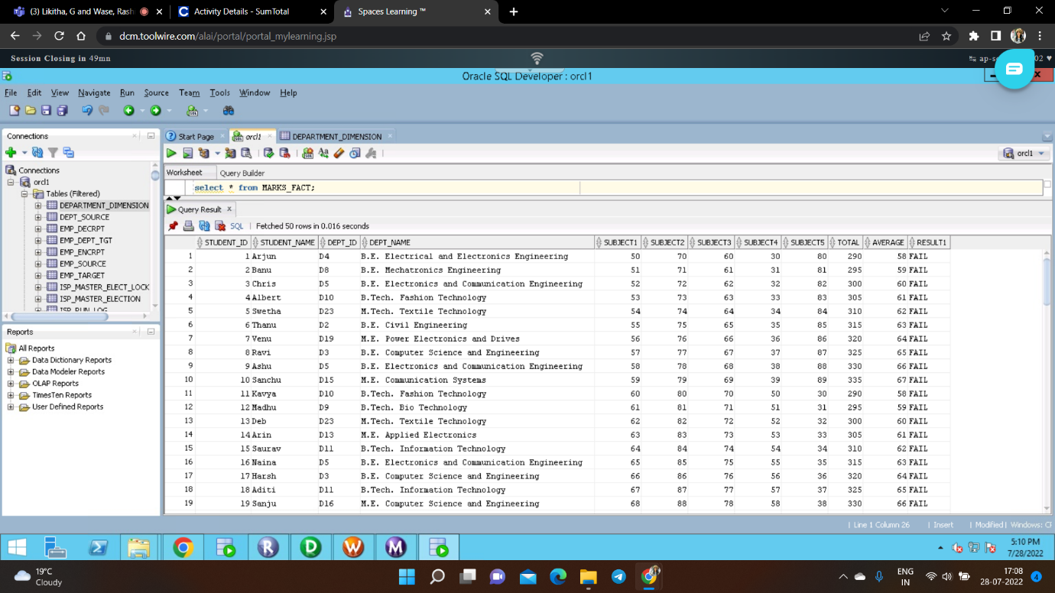

**Fig 15: Marks fact target Table**

**MAPPING**

The below figure shows the data flow from source to the target table by applying the necessary transformations to satisfy the business requirement.

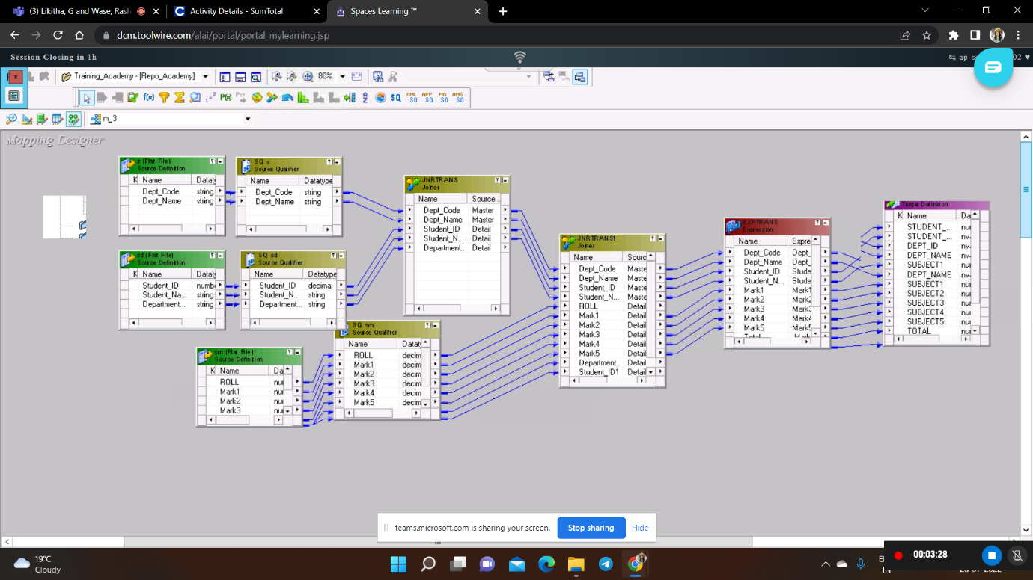

**Fig 16: Mapping 3**

**TRANSFORMATION**

The descriptions of the transformations used are mentioned in the table below.

|  |  |  |
| --- | --- | --- |
| **TRANSFORMATION**  **NAME** | **DESCRIPTION** | **TRANSFORMATION**  **LOGIC** |
| **JNR [Normal Join]**  **(1)** | TO JOIN DEPARTMENT_DETAILS (MASTER TABLE) AND STUDENT_DETAIL (DETAIL TABLE) | DEPT_CODE=DEPT_ID |
| **JNR [Normal Join]**  **(2)** | TO JOIN THE FIRST JOINER TABLE(MASTER TABLE) AND STUD_MARK (DETAIL TABLE) | DEPT_ID=DEPT_ID1  STUDENT_ID=STUDENT_ID1 |
| **EXP (Port Total)** | TO CALCULATE THE TOTAL MARKS OF EACH STUDENT, A NEW COLUMN NAMED AS ‘TOTAL’ IS CREATED. | MARK1+MARK2+MARK3+MARK4  +MARK5 |
| **EXP (Port Average)** | TO CALCULATE THE AVERAGE MARKS OF EACH STUDENT A NEW COLUMN ‘AVERAGE’ IS CREATED. | (MARK1+MARK2+MARK3+MARK4  +MARK5)/5 |
| **EXP (Port Result)** | TO DETERMINE THE RESULT OF EACH STUDENT, A NEW COLUMN NAMED AS ‘RESULT’ IS CREATED. | IIF(MARK1>=50 AND MARK2>=50 AND MARK3>=50 AND MARK4>=50 AND MARK5>=50,’PASS’,’FAIL’) |

**Table 8: Marks Fact Transformation Description**

**Workflow:** Below Figure shows the workflow which executes the mappings created in the designer.

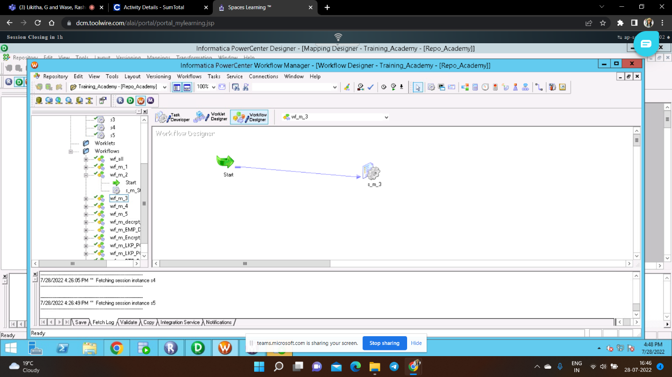

**Fig 17: Workflow 3**

###### Functional Requirement 4

**SUBJECT AVERAGE AGGREGATE TABLE**

### SOURCE

Under the fourth Functional requirement, to generate the Subject Average Aggregate Table we modified the provided source as per the requirement.

|  |  |  |
| --- | --- | --- |
| **SOURCE FILE NAMES** | **DESCRIPTION** | **SOURCE FILES** |
| Dept_Details.txt | This is a TAB delimited file containing 2 fields. |  |
| Student_Marks.txt | This is a TAB delimited file containing 8 fields. |  |

**Table 9: Subject Average Aggregate** **Source Description**



**Fig 18: Subject Average Aggregate** **Source Definition**

**TARGET**

The group table has been generated in the Oracle database by using the source files as mentioned above.

|  |  |  |
| --- | --- | --- |
| **TARGET NAME** | **DESCRIPTION** | **TARGET FILE** |
| tgt_Subject_Avg_Agg.txt | Contains contain average marks scored by students in all subjects by department. |  |

**Table 10: Subject Average Aggregate Target Description**



**Fig 19: Subject Average Aggregate Target Definition**

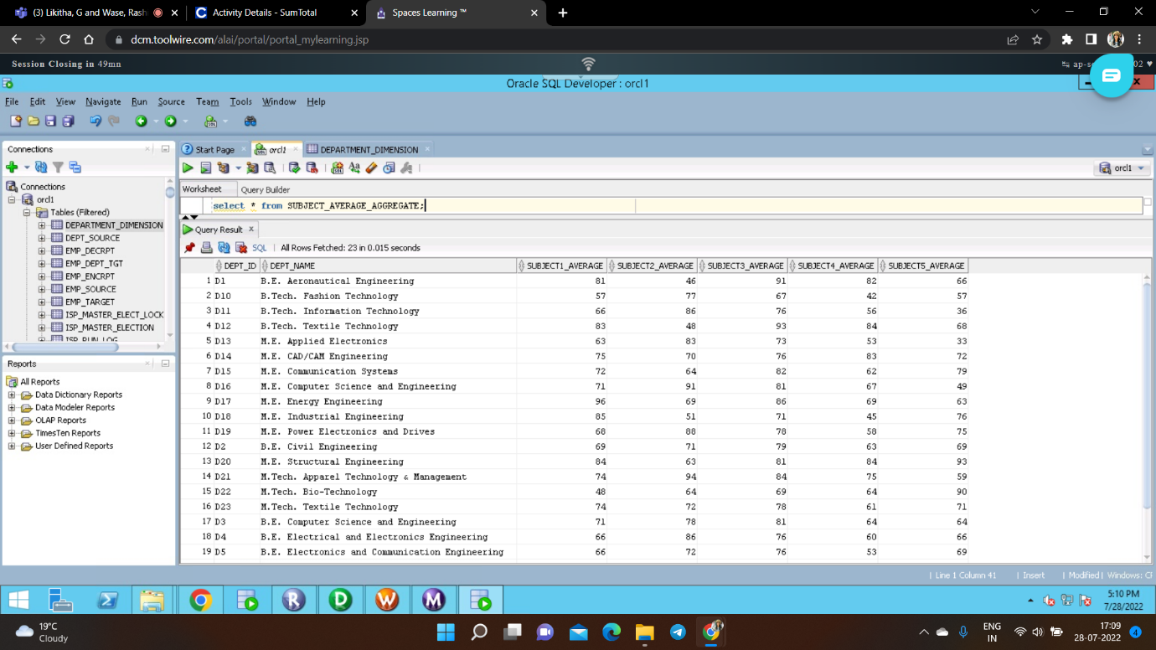

**Fig 20: Subject Average Aggregate Target Table**

**MAPPING**

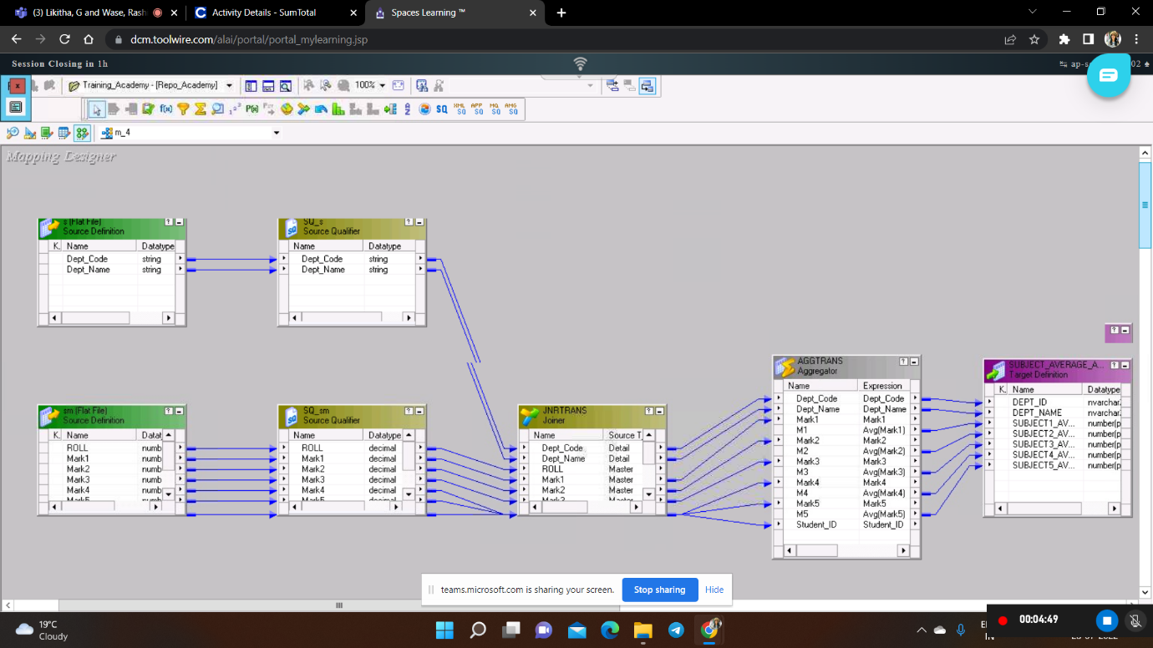

**Fig 21: Mapping 4**

**TRANSFORMATION**

The descriptions of the transformations used are mentioned in the table below.

|  |  |  |
| --- | --- | --- |
| **TRANSFORMATION**  **NAME** | **DESCRIPTION** | **TRANSFORMATION**  **LOGIC** |
| **JNR [Normal Join]** | This transformation is used to get input from two different source files based on a common column. | DEPT_CODE=DEPARTMENT_ID |
| **AGG** | This transformation is used to get average of marks of each subject. | AVG(Subject1)  **Group by:**  DEPT_CODE |

**Table 11: Subject Average Aggregate** **Transformation Description**

**Workflow:** Below Figure shows the workflow which executes the mappings created in the designer.

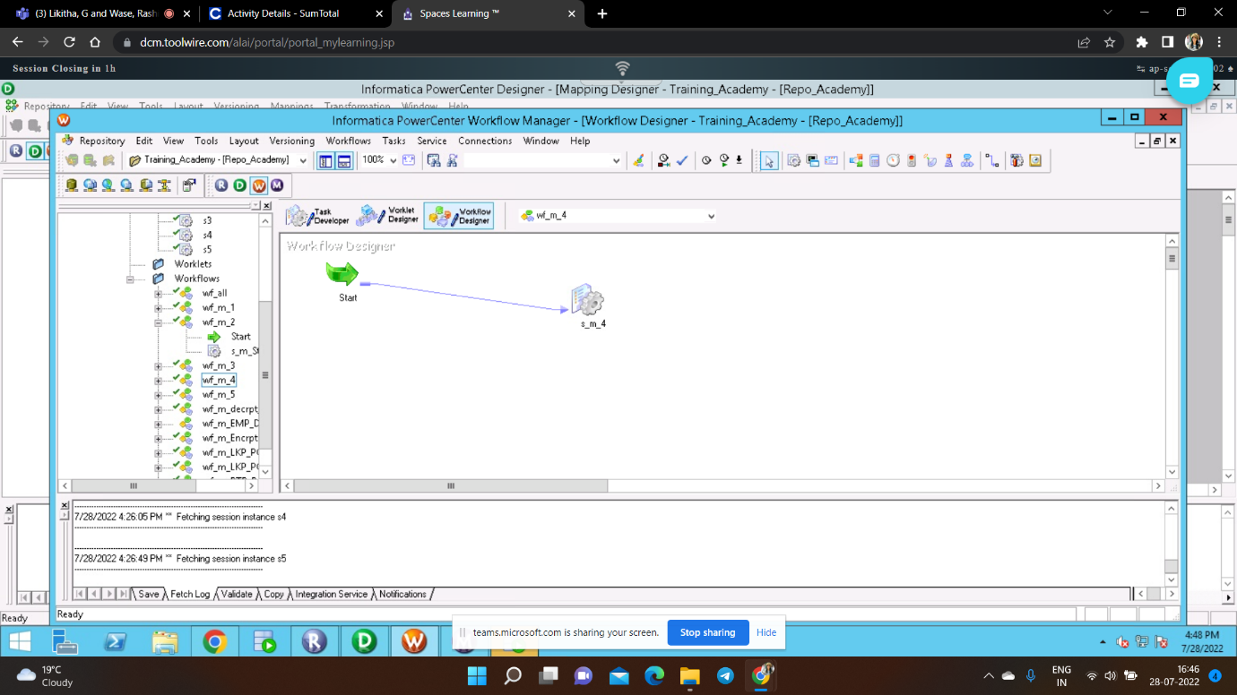

###### Fig 22: Workflow 4

###### Functional Requirement 5

**SUBJECT PASS PERCENTAGE AGGREGATE**

**SOURCE**

Under the fifth Functional requirement, to generate the Subject Pass Percentage Aggregate Table we created two Source flat files i.e.

|  |  |  |
| --- | --- | --- |
| **SOURCE FILE NAMES** | **DESCRIPTION** | **SOURCE FILES** |
| Dept_Details.txt | This is a tab delimited file containing 2 fields. |  |
| Student_Marks.txt | This is a tab delimited file containing 8 fields. |  |

**Table 12: Subject Pass Percentage Aggregate Source Description**



**Fig 23: Subject Pass Percentage Aggregate** **Source Definition**

**TARGET**

The Subject Pass Percentage Aggregate table has been generated in the Oracle database by using the source files as mentioned above.

|  |  |  |
| --- | --- | --- |
| **TARGET NAME** | **DESCRIPTION** | **TARGET FILE** |
| tgt_Subject_Pass_Percentage_Agg.txt | Contains pass percentage for each subject by department. |  |

**Table 13: Subject Pass Percentage Aggregate Target Description**



**Fig 24: Subject Pass Percentage Aggregate Target Definition**

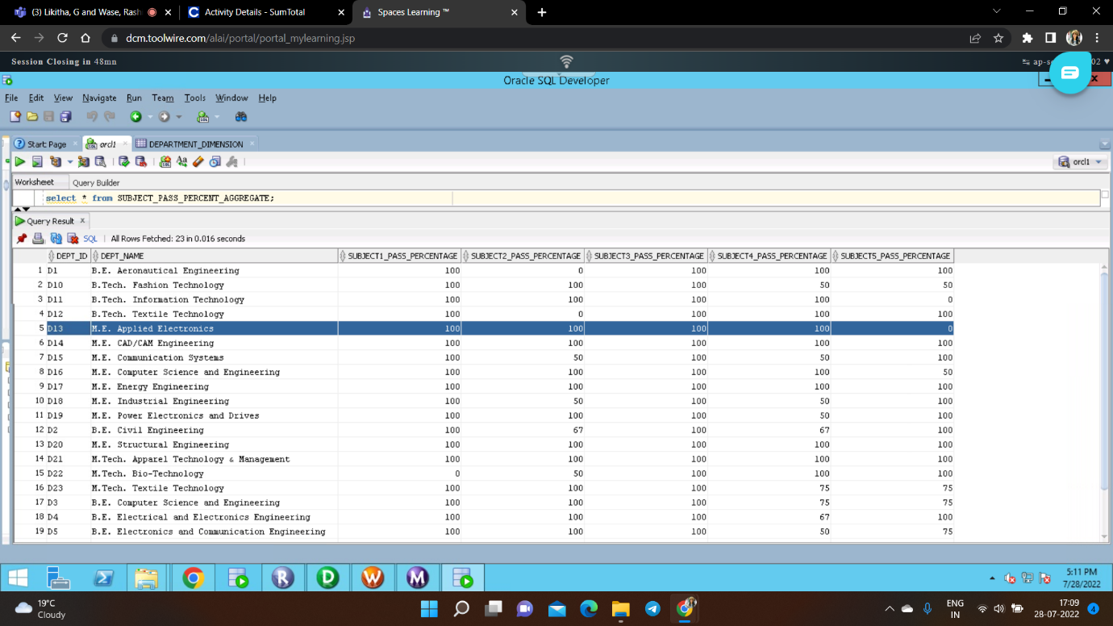

**Fig 25: Subject Pass Percentage Aggregate Target Table**

**MAPPING**

The below figure shows the data flow from source to the target table by applying the necessary transformations to satisfy the business requirement.

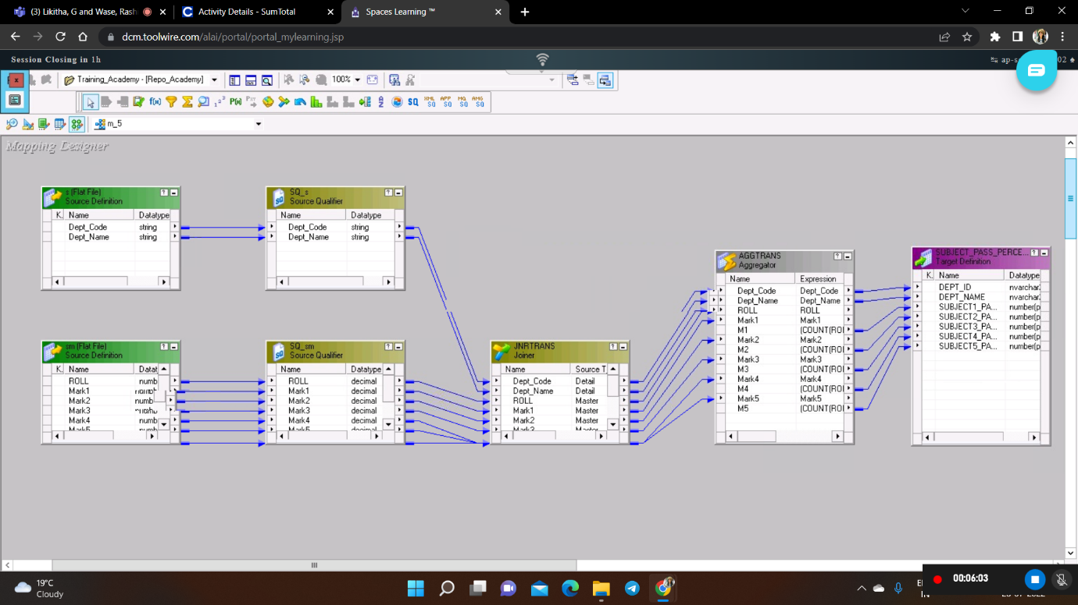

**Fig 26: Mapping 5**

**TRANSFORMATION**

The descriptions of the transformations used are mentioned in the table below.

|  |  |  |
| --- | --- | --- |
| **TRANSFORMATION**  **NAME** | **DESCRIPTION** | **TRANSFORMATION**  **LOGIC** |
| **JNR [Normal Join]** | This transformation is used to get input from two different source files based on a common column. | DEPT_CODE=DEPARTMENT_ID |
| **AGG** | This transformation is used to get average of marks of each subject. | (COUNT(ROLL,MARK1>=50)/ COUNT(ROLL))*100  Group by:  DEPT_CODE |

**Table 14: Subject Pass Percentage Aggregate Transformation Description**

**Workflow:** Below Figure shows the workflow which executes the mappings created in the designer.

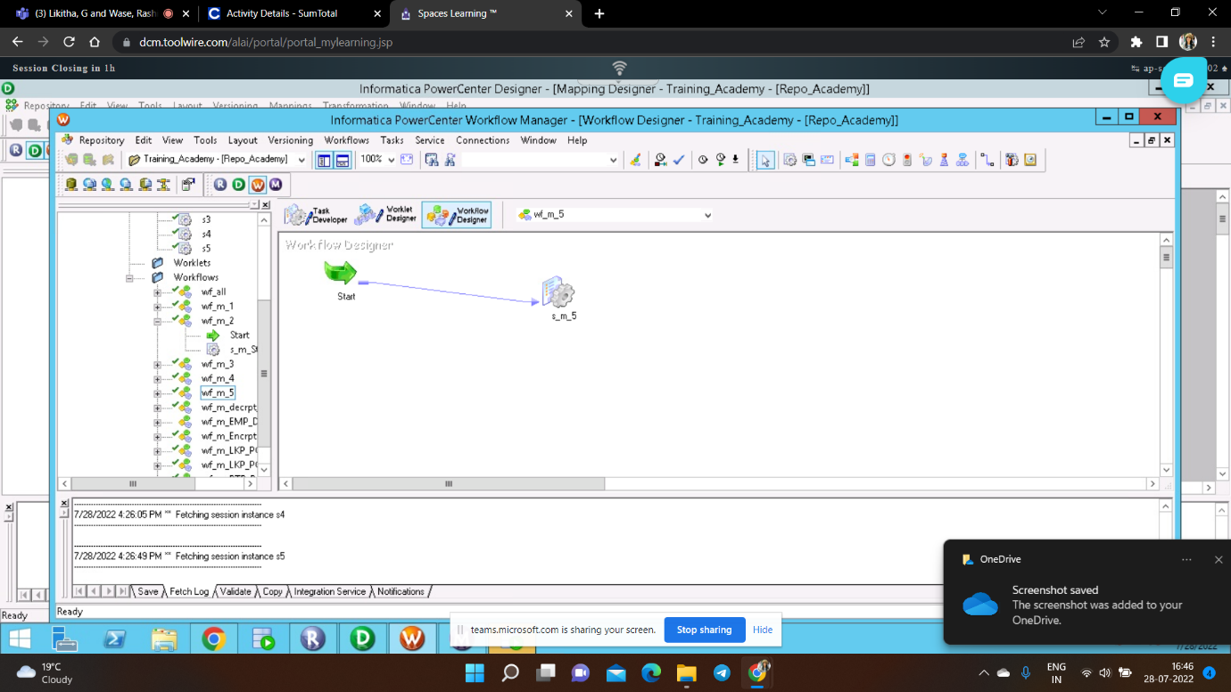

###### Fig 27: Workflow 5

###### INTEGRATED WORKFLOW

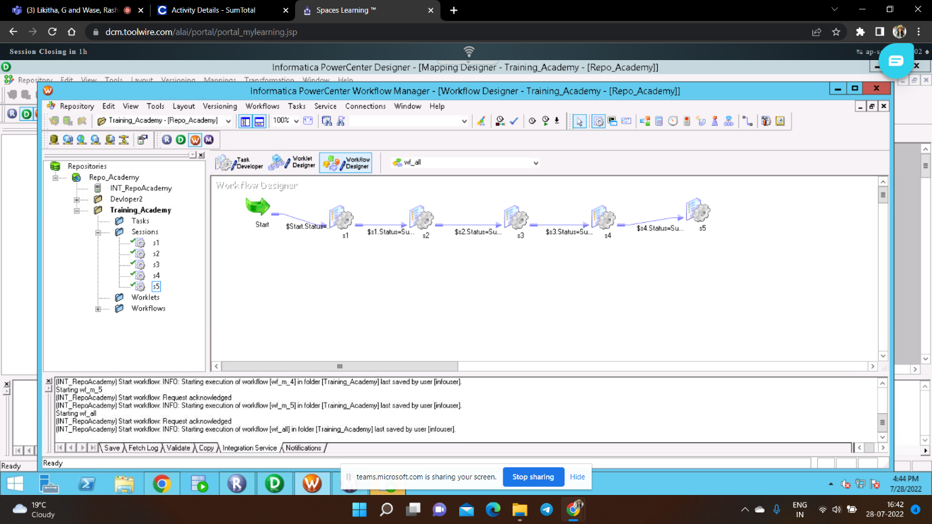

**Fig 28: Integrated Workflow Details**

#### INTEGRATED TASK DETAILS

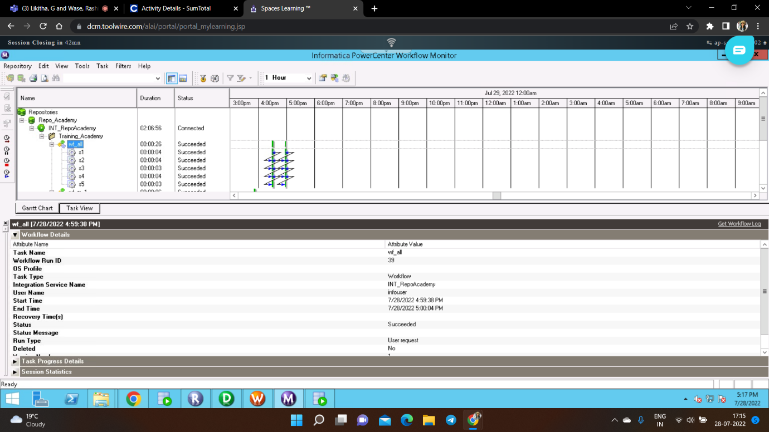

**Fig 29: Integrated Task Details-** **Gantt Chart View**

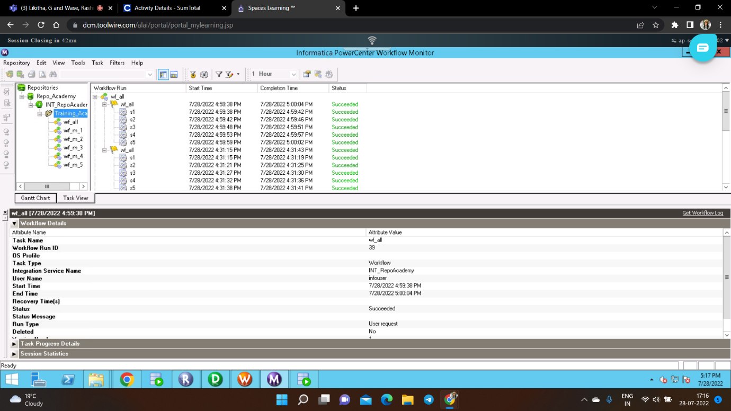

**Fig 30: Integrated Task Details- Task View**

##### DESIGN CONSTRAINTS

1. Workflow should succeed only if all sessions have completed successfully

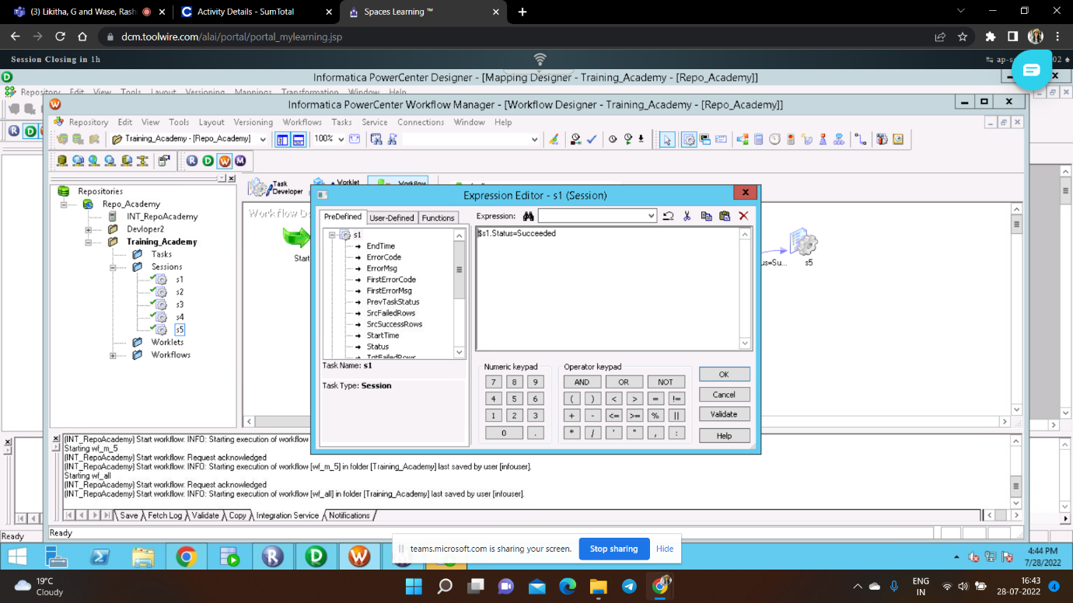

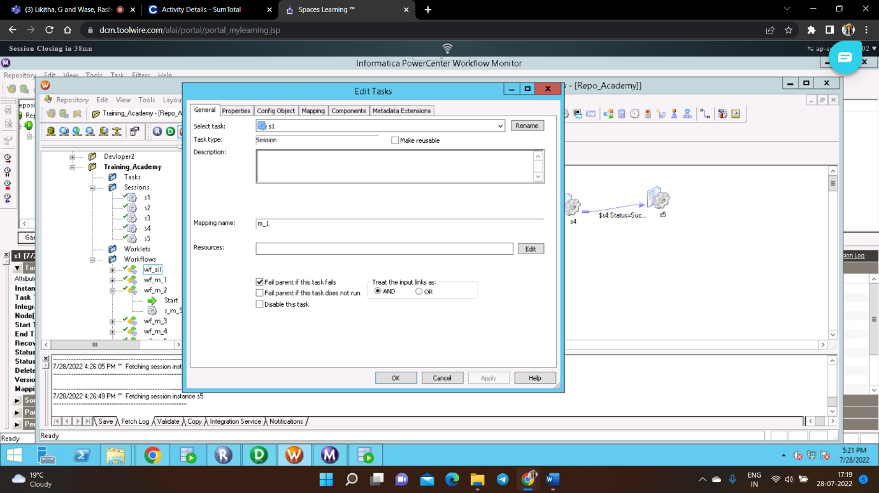

**2. Schedulers**

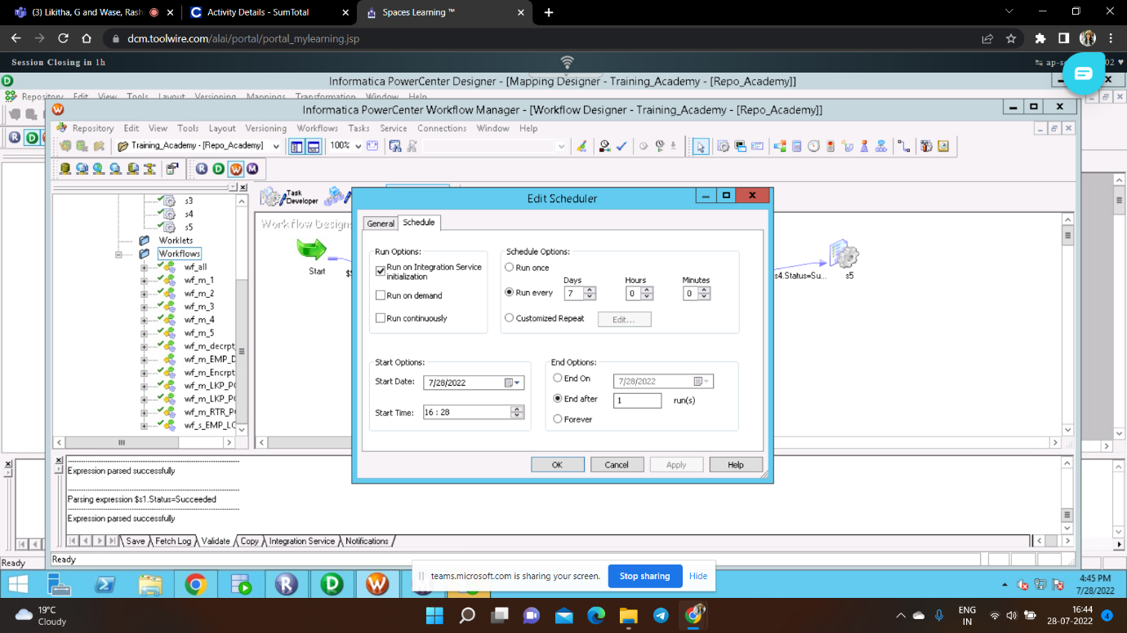

##### CONCLUSION

All business requirements were taken into account when developing the system **"STUDENT REPORT".** By creating five target databases and testing the given restrictions, the project's main goal has been accomplished. The system has been operated only in accordance with the functional specifications outlined in the source document and has been expanded to accommodate new features. A data warehouse called the Student Report was created to manage the data of various students enrolled in educational institutions.